Project Synopsis

on

# Employee Drowsiness Detection System

Submitted as a part of course curriculum for

**Bachelor of Technology**

In

## Computer Science



**Submitted by**

ASHU VERMA (2000290120045)

CHANDAN KUMAR GUPTA (2000290120058)

DAKSH KUMAR (2000290120060)

**Under the Supervision of**

Ms. ANSHULA GUPTA

Assistant Professor, CS

## KIET Group of Institutions, Ghaziabad

## Department of Computer Science

**Dr. A.P.J. Abdul Kalam Technical University**

**2022-2023**

## DECLARATION

We hereby declare that this submission is our work and that, to the best of our knowledge and belief, it contains no material previously published or written by another person nor material which to a substantial extent has been accepted for the award of any other degree or diploma of the university or other institute of higher learning, except where due acknowledgement has been made in the text.

Signature of Student:

**Name: Ashu Verma**

**Roll No.: 2000290120045**

Date: 14-11-2022

Signature of Student:

**Name: Chandan Kumar Gupta**

**Roll No.: 2000290120058**

Date: 14-11-2022

Signature of Student:

**Name: Daksh Kumar**

**Roll No.: 2000290120060**

Date: 14-11-2022

## CERTIFICATE

This is to certify that Project Report entitled “**Drowsiness Detection**” which is submitted by **Ashu Verma, Chandan Kumar Gupta, Daksh Kumar** in partial fulfilment of the requirement for the award of degree B. Tech. in Department of Computer Science of Dr A.P.J. Abdul Kalam Technical University, Lucknow is a record of the candidates own work carried out by them under my supervision. The matter embodied in this report is original and has not been submitted for the award of any other degree.

**Date: 12-11-2022 Supervisor Signature**

Ms. Anshula Gupta

(Assistant Professor, CS)

## ACKNOWLEDGEMENT

It gives us a great sense of pleasure to present the synopsis of the B.Tech Mini Project undertaken during B.Tech. Third Year. We owe a special debt of gratitude to Ms. **Anshula Gupta Assistant Professor, CS** Department of Computer Science, KIET Group of Institutions, Delhi- NCR, Ghaziabad, for her constant support and guidance throughout the course of our work. Her sincerity, thoroughness and perseverance have been a constant source of inspiration for us. It is only his/her cognizant efforts that our endeavours have seen the light of the day.

We also take the opportunity to acknowledge the contribution of Dr. Ajay Kumar Shrivastava, Head of the Department of Computer Science, KIET Group of Institutions, Delhi- NCR, Ghaziabad, for his full support and assistance during the development of the project. We also do not like to miss the opportunity to acknowledge the contribution of all the faculty members of the department for their kind assistance and cooperation during the development of our project.

Last but not the least, we acknowledge our friends for their contribution to the completion of the project.

Signature:

Name: Ashu Verma

Roll No.: 2000290120045

Date: 14-11-2022

Signature:

Name: Chandan Kumar Gupta

Roll No.: 2000290120058

Date: 14-11-2022

Signature:

Name: Daksh Kumar

Roll No.: 2000290120060

Date: 14-11-2022

## ABSTRACT

In this project we are trying to develop a system which will detect fatigue of the human and it will give warning. Due to drowsiness, office employees are not able to meet the deadlines of the projects allotted to them. Due to the drowsiness in offices the cost of company increases due to the delay in their projects. In this project the system will continuously monitor the eye of the human using a camera. By applying a perfect algorithm, we can detect the symptoms of drowsiness in peoples, and we will give a warning to avoid the person to get into sleep.

In this project the warning will only be deactivated manually. For this a deactivation dialog box will appear which will have some basic operation for employee or we can add a device which will give an alert signal and that signal will stop only when the employee manually deactivates the signal.

Moreover, if the person is drowsy, he/she may give the wrong answer in the dialog box. We can judge this by plotting a graph in time domain. If all the three input variables show a possibility of fatigue at one moment, then a warning is given in form of text or sound. This will directly give an indication of drowsiness.

|  |  |
| --- | --- |
| **TABLE OF CONTENTS** | Page No. |
| TITLE PAGE .................................................................................................................... | i |
| DECLARATION .............................................................................................................. | ii |
| CERTIFICATE …........................................................................................................... | iii |
| ACKNOWLEDGEMENT.................................................................................................. | iv |
| ABSTRACT...................................................................................................................... | v |
| LIST OF FIGURES......................................................................................................... | vi |
| LIST OF ABBREVIATIONS ………..…………………………………………………. | vii |
| CHAPTER 1 INTRODUCTION | 1-n |
| 1.1. Introduction ……………………................................................... | 1 |
| 1.2 Problem Statement.…………………….......................................  1.2. Objective………………………………………………………… | 2 |
| 1.3. Scope…………………………………………………………….. | 3 |
| CHAPTER 2 LITERATURE REVIEW…………………………………………….... | 7-p |
| CHAPTER 3 PROPOSED METHODOLOGY …………………………………........ | 8-m |
| 3.1 Flowchart  3.2 Algorithm Proposed | 10 |
| CHAPTER 4 TECHNOLOGY USED ………..………………………..……………….  CHAPTER 5 CONCLUSION ….......................................................................................  REFERENCES….............................................................................................................. | 12 |

**CHAPTER-1**

**INTRODUCTION**

Drowsiness behaviours which are related to fatigue are in different forms like eyes closed, head nodded or different brain activity. Due to the problem of drowsiness many company faces failure issue. So we can either measure change in physiological signals, such as heart rate and blinking of eyes to monitor drowsiness.

All the former technique, which are more accurate are not realistic for example Electroencephalography*(EEG) and Electrocardiography (ECG) these are not realistic as they require equipment and highly sensitive electrodes would have to be attached directly to the person. This method of detecting drowsiness will be very annoying and distracting for a person. The second method for measuring drowsiness is by measuring physical changes like eyes open/closed, yawning which can be detected and measured using camera. By detecting the time of blinking of eyes one can say person is drowsy or not. Thus, by continuously monitoring the eyes of the person one can detect the sleepy state of person and a timely warning can be issued for the person and a small operation can be given to make person out of drowsiness.

**PROBLEM STATEMENT**

In some corporate offices many projects meet failure, some due to the drowsiness. It is considered to be one of the problem through which companies faces failure of the project.

In a company if there are employee which are sleepy in nature then the productivity of company decreases, also these employee are very slow and reaction time is very low. It leads to adverse impact on the productivity of a particular organization. Also, sleepy employees have worse adaptive nature. That means they will not be able to adapt changing situation easily. Additionally, these employees will have trouble for doing multitasking or there is a problem to quickly switch between different tasks that are provided within a company.

These are the main problems that occur due to drowsiness. So, there should be a system that keeps real time record and alert to the respective person so that there should not be any problem due to drowsiness.

**OBJECTIVES**

In this project we are going to develop a Sleep Detection System that is proposed as specific counter measures to control the drowsiness that are associated with an employee. In this system we will use different techniques for detecting employee’s drowsiness while working also it will give notification when an employee will reach at critical level of drowsiness.

Detection can be done using facial expression and characteristics. In this detection we can use SVM and CNN. So we can use either of the algorithms for this detection.

**SCOPE**

1. There is a vast scope of this project we can use drowsiness detection system in different manner as the main scope is we can use it in different organisations for sleepy employee.
2. We can use it in driver sleepy detection to prevent accidents from happening.
3. Some other field is there we can use this system is on all the OTT platforms for detecting if a viewer is sleepy or not. If the viewer is sleepy then the streaming will automatically stop.

**CHAPTER 2**

**LITERATURE REVIEW**

* 1. **Driver Drowsiness Detection System and Techniques**

In this research the author tries to solve the problem for the driver who does not take regular breaks when driving long distances run a high risk of becoming drowsy a state which they often fail to recognize early enough according to the experts. Studies show that around one quarter of all serious motorway accidents are attributable to sleepy drivers in need of a rest, meaning that drowsiness causes more road accidents than drink-driving. Attention assist can warn of inattentiveness and drowsiness in an extended speed range and notify drivers of their current state of fatigue and the driving time since the last break, offers adjustable sensitivity and, if a warning is emitted, indicates nearby service areas in the COMAND navigation system. Based on Acquisition of video from the camera that is in front of driver perform real-time processing of an incoming video stream in order to infer the driver’s level of fatigue if the drowsiness is Estimated then the output is send to the alarm system and alarm is activate.

**2.2 Parameter Estimation In Crystal Sugar Production With MLR, ANN and ANFIS**

In this research paper the author tries to make the sugar production estimation using machine learning as the sugar production process is a complex process in which many variables interact. The cost and time requirements of complex processes are reduced by computer-based modelling techniques and necessary actions can be taken regarding the obtained product quality. In this study for the crystallization stage, solution colour which is one of the quality control criteria for sugar production was predicted by multiple linear regression (MLR), artificial neural network (ANN) and adaptive neural fuzzy inference system (ANFIS).

Main goal of the study is the prediction of solution colour at crystallization stage of sugar production by MLR, ANN and ANFIS. The correlation coefficient (R) value of ANFIS was more significant than the ANN and MLR, which is found as 0.99, 0.82 and 0.6.

**2.3 Research on Machine Learning and Its Algorithms and Development**

In this research the author does the research on Machine learning and its algorithm. It analyses the basic classification of machine learning, including supervised learning, unsupervised learning, and reinforcement learning. Through the development of theoretical systems, further improvement of autonomous learning capabilities, the integration of multiple digital technologies, and the promotion of personalized custom services, the purpose is to improve people's awareness of machine learning and accelerate the speed of popularization of machine learning.

The rapid development of science and technology, artificial intelligence has also ushered in new development opportunities. Machine technology based on computer technology incorporates multidisciplinary theoretical knowledge, such as statistics and algorithm complexity, which further strengthens the functional attributes of artificial intelligence.

**2.4 Alzheimer Disease (AD) Detection through Immersive Technology to Prevent Human Risk**

Author depicts the graphical way to proposed approach for Alzheimer’s detection in patient from long distance using immerse environment concept. This research study is based on immerse technology and uses. Alzheimer’s disease (AD) is the form of neurodegenerative dementia that heavily affects mental state, personality, behaviour and the cognition of someone with the disease. AD is the third most expensive chronic diseases after cancer and chronic heart disease. AD is devastating, and increasingly widespread because of expensive cost of treatment and detection with high mortality rate. AD is as yet incurable, but there are several ways to make patients' lives more bearable and one of those ways is with the help of immerse technology. Immerse technology represents an innovative and revolutionary technology capable of providing new application techniques in different disciplines. Currently, there is a sharp increase in the use of immerse technology within the medical field for motor and cognitive rehabilitation. Dementia is one of the most widespread neurodegenerative brain diseases worldwide with numbers destined to soar over the decades, so much so that the World Health Organization has defined dementia as a global public health priority. 04-20 06-20 08-20 10-20 12-20 02-21 04-21 06-21 08-21 10-21 12-21 Preparation of Research Paper Presentation of Research Paper Submission of Paper to Ethics Committee Data Collection/ Questionnaire Data Mining Final Submission The use of immerse technology to makes it possible to reveal quite accurately and early violations of spatial and episodic memory, executive functions and attention, motor functions and balance, and the fulfilment of everyday tasks. Moreover, studies have shown that training in immerse environments, which is a simple game task for the user in a variety of conditions, can significantly improve all these functions in people with AD.

**2.5 An end to end framework for information extraction from Italian resumes**

In this research paper the author does the research on the automatic resume selection process. Nowadays, recruitment processes are increasingly being automated by intelligent systems which provide best candidates for companies’ open positions, and vice versa.

* Recruitment process can be improved by techniques extracting information from resumes.
* An end-to-end framework has been designed for information extraction from resumes.
* Relevant information is extracted through a NER task on semantically consistent parts.
* Our framework has been evaluated on a real resume dataset, showing promising results.

**2.6 Advanced machine-learning techniques in drug discovery**

In this research paper the researcher has make us aware of that the machine learning has emerged as a vital tool over the past two years. These techniques have mathematical and statistical background. Machine learning techniques can detect patterns in large volumes of data.

Machine learning popularity among drug discovery continues to grow and yield impressive results. The application of ML applied in the field of drug discovery facilitates research in numerous avenues.

The success of ML lies in its ability to decode patterns in complex and large volume data sets.

Conventional MLTs in drug discovery:

1. K nearest neighbour
2. Decision tree
3. Random forest
4. Support Vector Machine
5. Artificial neural networks
6. Principal component analysis
7. And k-means

Even though simple, these traditional ML techniques have their own drawbacks. K-NN suffers from the curse of dimensionality.

**2.7 Enhanced Drowsiness Detection Using Deep Learning**

In this paper, deep-learning-based driver-drowsiness detection for brain-computer interface (BCI) using functional near-infrared spectroscopy is investigated. The passive brain signals from drowsiness were acquired from 13 healthy subjects while driving a car simulator. The brain activities were measured with a continuous-wave fNIRS system, in which the prefrontal and dorsolateral prefrontal cortices were focused. Deep neural networks (DNN) were pursued to classify the drowsy and alert states. For training and testing the models, the convolutional neural networks (CNN) were used on color map images to determine the best suitable channels for brain activity detection in 0~1, 0~3, 0~5, and 0~1 second time windows. The CNN architecture resulted in an average accuracy of 99.3%, showing the model to be capable of differentiating the images of drowsy/non-drowsy states. The proposed approach is promising for detecting drowsiness and in accessing the brain location for a passive BCI.

**2.8 Survey on Lie Group Machine Learning**

In this research paper the author researches on Lie group machine leaning. Lie group machine learning is recognized as the theoretical basis of brain intelligence, brain learning, higher machine learning, and higher artificial intelligence. Sample sets of Lie group matrices are widely available in practical applications. Lie group learning is a vibrant field of increasing importance and extraordinary potential and thus needs to be developed further. This study aims to provide a comprehensive survey on recent advances in Lie group machine learning. In addition, we introduce the special application of Lie group machine learning in image processing. Overall, this survey aims to provide an insightful overview of state-of-the-art development in the field of Lie group machine learning. It will enable researchers to comprehensively understand the state of the field, identify the most appropriate tools for particular applications, and identify directions for future research.

**2.9 PREDICTION OF COMBINED CYCLE POWER PLANT ELECTRICAL OUTPUT POWER USING MACHINE LEARNING REGRESSION ALGORITHMS**

**BY-**Nader S. Santarisi Doctor, Associate Professor* Sinan S. Faouri Corresponding author

The main objective of this research is to predict the full load electrical power output of CCPP depending on four features i.e temperature, humidity, pressure, and vacuum.

There are many reasons why combined cycles are more and more popular and being taken under consideration as one of the main types of power plants. The gas turbine compresses air and mixes it with fuel that is heated to a very high temperature. The hot air-fuel mixture moves through the gas turbine that drives an electricity generator. Furthermore, it can be integrated in a dynamic condition monitoring system in which the online performance is compared to the derived model and any deviations are diagnosed and inspected.

Learning algorithm used is linear regression for working of this prediction model. Linear regression was the first type of regression analysis to be studied rigorously, and to be used extensively in practical applications.

**2.10 Transforming healthcare with big data analytics and artificial intelligence**

**BY**- Nishita Mehta, Anil Pandit, Sharvari Shukla

This research paper focuses on the importance and need of technologies in the health care sector for the better use of big data and to gain valuable products out of it.

In the healthcare industry, various sources for big data include hospital records, medical records of patients, results of medical examinations, and health care devices, Biomedical research. And the right management of data for the implementation is crucial. There are various challenges at every step of handling data that can only be surpassed by using high-end computing solutions for big data analysis.

Data and information have always been crucial in each & every field. Now with digitalization & technologies are adding up to it and generates a significant portion of big data relevant to public healthcare. That is why knowing about it and assessing what can be achieved using this data are mandatory. So, to provide relevant ways for improving the health sector, healthcare providers are required to be fully equipped with the required infrastructure to generate and analyse big data.

**CHAPTER-3**

**PROPOSED METHODOLOGY**

**3.1FLOWCHART:**

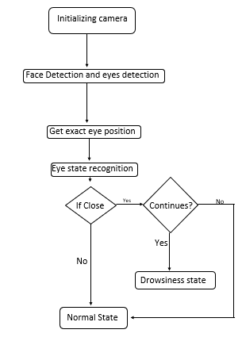

**3.1 Methodology:**

A different type of methodologies has been developed to find out drowsiness.

3.1.1 Physiological level approach:

This technique is an intrusive method wherein electrodes are used to obtain pulse rate, heart rate and brain activity information. ECG is used to calculate the variations in heart rate and also detect different conditions for drowsiness. The correlation between different signals such as ECG (electrocardiogram), EEG (electroencephalogram), and EMG (electromyogram) are made and then the output is generated whether the person is drowsy or not.

3.1.2 Behavioural based approach:

In this technique eye blinking frequency, head pose, position of eyelid etc. of a person is monitored through a camera and the person is alerted if any of these drowsiness symptoms are detected.

**3.2 ALGORITHM:**

1. Image sequence input to camera.

2. Face detection takes place

3. Exact location is fetched

4. Eye state recognition using Binary pattern method and Edge detection method.

5. If eyes are closed and continues to be closed for predefine threshold, Drowsiness state is detected

6. Otherwise person is in normal state

7. Repeat the process

**CHAPTER-4**

**TECHNOLOGY USED**

4.1 TensorFlow:

It is an open-source software library for dataflow programming across a range of tasks. It is a symbolic math library, and is also used for machine learning applications such as neural networks. It is used for both research and production. TensorFlow computations are expressed as stateful dataflow graphs. The name TensorFlow derives from the operations that such neural networks perform on multidimensional data arrays. These arrays are referred to as "tensors".

4.2 Machine learning:

Machine learning is the kind of programming which gives computers the capability to automatically learn from data without being explicitly programmed. This means in other words that these programs change their behaviour by learning from data. Python is clearly one of the best languages for machine learning. Python does contain special libraries for machine learning namely scipy, pandas and numpy which great for linear algebra and getting to know kernel methods of machine learning. The language is great to use when working with machine learning algorithms and has easy syntax relatively.

4.3 Machine learning categories:

4.3.1 Supervised learning: The machine learning program is both given the input data and the corresponding labelling. This means that the learn data has to be labelled by a human being beforehand.

4.3.2 Unsupervised learning No labels are provided to the learning algorithm. The algorithm has to figure out a clustering of the input data.

4.4 OpenCV:

OpenCV stands for Open Source Computer Vision. It's an Open Source BSD licensed library that includes hundreds of advanced Computer Vision algorithms that are optimized to use hardware acceleration. OpenCV is commonly used for machine learning, image processing, image manipulation, and much more. OpenCV has a modular structure. There are shared and static libraries and a CV Namespace. In short, OpenCV is used in our application to easily load bitmap files that contain landscaping pictures and perform a blend operation between two pictures so that one picture can be seen in the background of another picture. This image manipulation is easily performed in a few lines of code using OpenCV versus other methods. OpenCV.org is a must if you want to explore and dive deeper into image processing and machine learning in general.

4.5 Face Detection:

Object Detection using Haar feature-based cascade classifiers is an effective object detection method proposed by Paul Viola and Michael Jones in their paper, "Rapid Object Detection uses a Boosted Cascade of Simple Features" in 2001. It is a machine learning based approach where a cascade function is trained from a lot of positive and negative images. It is then used to detect objects in other images. Here we will work with face detection. Initially, the algorithm needs a lot of positive images (images of faces) and negative images (images without faces) to train the classifier. Then we need to extract features from it. For this, Haar features shown in the below image are used. They are just like our convolutional kernel. Each feature is a single value obtained by subtracting sum of pixels under the white rectangle from sum of pixels under the black rectangle.

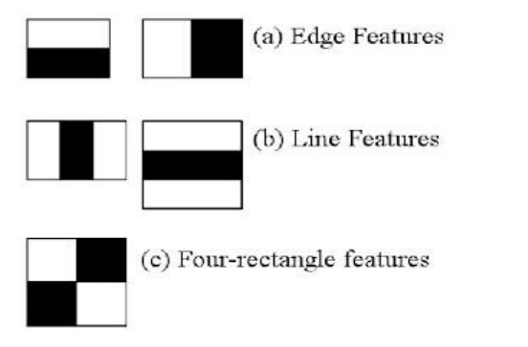

A cascaded Adaboost classifier with the Haar-like features is exploited to find out the face region. First, the compensated image is segmented into numbers of rectangle areas, at any position and scale within the original image. Due to the difference of facial feature, Haar-like feature is efficient for real-time face detection. These can be calculated according to the difference of sum of pixel values within rectangle areas. The features can be represented by the different composition of the black region and white region. A cascaded Adaboost classifier is a strong classifier which is a combination of several weak classifiers. Each weak classifier is trained by Adaboost algorithm. If a candidate sample passes through the cascaded Adaboost classifier, the face region can be found. Almost all of face samples can pass through and non-face samples can be rejected

4.6 Eye detection:

Object detection using Haar feature-based cascade classifiers is more than a decade and a half old. OpenCV framework provides a pre-built Haar and LBP based cascade classifiers for face and eye detection which are of reasonably good quality. pre-built Haar/LBP cascades have a high false positive rate which might make them unsuitable for many use-cases. Fortunately, it is possible to train an eye detector with very high accuracy and low false positive rates for many cases with OpenCV.

4.6.1 Recognition of Eye's State:

The characteristic feature of the eye is extracted to recognize the eye's state. In general, the state of left eye is equal to right one at the same time. Therefore, we only consider one eye’s state in one frame. This consideration is also useful to the reduction of computational complexity. In this step, two schemes are adopted: (1) binary pattern and (2) the Canny’s edge detection

The eye image is converted to binary pattern based on the threshold value T. 𝑇 = {∑ Xi 𝑛 𝑖=1 }/𝑛

Here n is the number of pixels in the eye region and xi is the pixel value of the position i in the region. There are n pixels in the eye region. If the pixel value of P is greater than the threshold T, P will be set as white, 1. Otherwise P will be set as 0. Its definition is shown as

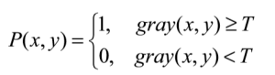

When the conversion of eye image is completed, the height of the eyelids is utilized to determine the eye's state.

Binary pattern : (a)-(b) open eye and (c)-(d) closed eye

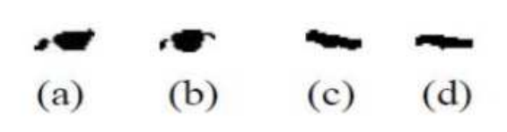

The Canny’s edge detection algorithm is well known for its ability to generate continuous edge. First, the image is smoothed by Gaussian convolution.

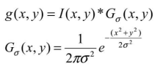

Where σ is a scale parameter. Then, the magnitude and orientation of the edge are calculated by the differential filter. The final edge image is obtained by edge information of multiple scale σ. Finally, the numbers of edge points are summed for recognizing the eye's state.

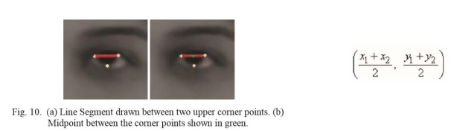

4.6.2 Eye Blink Detection:

1) Grayscale Conversion:

The coloured eye image is first converted to grayscale. Gray scale conversion algorithms use to convert the coloured image to grayscale.

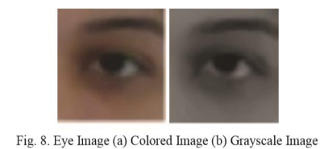

Corner Detection Corners are defined as intersection of two edges. We propose an eye blink detection algorithm that uses the two eye corner points and one point at the lower eye lid. To detect these points, Harris Corner Detector has been used. The reason for using Harris Corner Detector is one of the most used corner and interest point detector and is invariant to illumination variation, image noise, scale and rotation.

This corner detector makes use of the fact that a corner is simply the point where two edges intersect. In other words, it is the point at which the two edges change direction. The image gradient has an increased variation in both directions, which can be used to detect it. This “variation” is determined by Harris Corner Detector. On applying the Harris Corner Detector on the input eye image, we get the points as indicated in fig.,

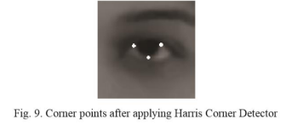

2) Midpoint Calculation A midpoint is defined as the middle or Centre point of a line segment. Once all the required points have been found, the next step would be to find midpoint between the two upper corner points. Let (X1, Y1) be the coordinates of upper left corner and (X2,Y2) be the coordinates of the upper right corner. A line segment is drawn between these two points. The midpoint of this line segment can be calculated using the following formula,

3) Distance Calculation:

Distance is a mathematical description of how far objects are from each other. As next step, we find distance of the midpoint from the point at lower eyelid. In analytic geometry, distance between two or more points is calculated by using the distance

formula given by the Pythagorean Theorem. The distance between two points (X1, Y1) and (X2, Y2) is given as:

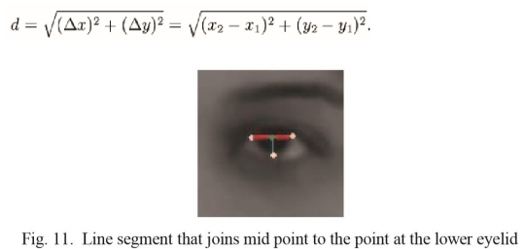

4) Eye State Determination:

Finally, the decision for the eye state is made on the basis of distance ’d’ calculated in the previous step. If the distance is zero or is close to zero, the eye state is classified as “closed” otherwise the eye state is identified as “open”.

4.7 Drowsiness Detection:

The last step of the algorithm is to determine the person’s condition on the basis of a pre-set condition for drowsiness. The average blink duration of a person is 100-400 milliseconds. This is 0.1-0.4 of a second. Hence if a person is drowsy his eye closure must be beyond this interval. We set a time frame of 5 seconds. If the eyes remain closed for five or more seconds, drowsiness is detected and alert pop regarding this is triggered.

**CHAPTER-5**

**CONCLUSION**

In this project we are able to produce a system that will give notification if a person is feeling sleepy. Detection of drowsiness is done successfully. By making of this project we have we are able to learn about TensorFlow, OpenCV, and implementation of canny algorithm. So on my final count we will later on add some extra fields by sending the daily drowsiness report to the Hr department so that the certain action will be taken on the basis of the score. As on the employee fell asleep our system keeps on alerting its windows and opening to solve some problem on the basis of the day module.

**References**

[1] <https://ieeexplore.ieee.org/document/7880030>

[2] <https://sci-hub.tw/https://ieeexplore.ieee.org/document/7396336?reload=true>

[3] [www.google.com](http://www.google.com)

[4] <https://realpython.com/face-recognition-with-python/>

[5] <https://www.pyimagesearch.com/2017/04/24/eye-blink-detection-opencv-python-dlib/>

[6] <https://github.com/tahaemara/sleep-detection/blob/master/README.md>

[7] <https://ieeexplore.ieee.org/document/7396336?reload=true>

[8] <https://github.com/mans-men/eye-blink-detection-demo>

[9] <https://docs.opencv.org/3.4/d7/d8b/tutorial_py_face_detection.html>

[10] <https://www.learnopencv.com/training-better-haar-lbp-cascade-eye-detector-opencv/>

[11]<https://blog.goodaudience.com/real-time-face-and-eyes-detection-with-opencv-54d9ccfee6a8>

[12] <https://www.seeingmachines.com/technology/>

[13] <https://eyegaze.com/tag/lc-technologies>